**Lab Task: Database Normalization Using a University Database**

**Objective**

Learn and apply the principles of normalization (1NF, 2NF, and 3NF) by restructuring a university database to eliminate anomalies and redundancy.

**Scenario**

You are given a raw dataset for a university system that tracks student enrollments, courses, instructors, and departments. Your task is to identify the issues in the dataset and apply normalization techniques to achieve a well-structured database.

**Dataset (Unnormalized Table)**

| **Enroll**  **ment**  **ID** | **Student**  **ID** | **Student**  **Name** | **Student**  **Phone** | **Course**  **ID** | **Course**  **Name** | **Credits** | **Inst-**  **ructor**  **ID** | **Inst**  **ructor**  **Name** | **Dptt**  **ID** | **Dptt**  **Name** | **Smstr** | **Grade** |
| --- | --- | --- | --- | --- | --- | --- | --- | --- | --- | --- | --- | --- |
| 1 | S001 | John Smith | 555-1234 | C001 | Database Systems | 4 | I001 | Dr. Brown | D001 | CS | Fall 2024 | A |
| 2 | S002 | Jane Doe | 555-5678 | C002 | Data Structures | 3 | I002 | Dr. Green | D001 | CS | Fall 2024 | B |
| 3 | S001 | John Smith | 555-1234 | C002 | Data Structures | 3 | I002 | Dr. Green | D001 | CS | Fall 2024 | A |
| 4 | S003 | Alice White | 555-9012 | C003 | Algorithms | 3 | I003 | Dr. Black | D002 | Maths | Fall 202 Fall | B |

**Creating The Above Table in SQL:**

First of all I have created the database for the table:

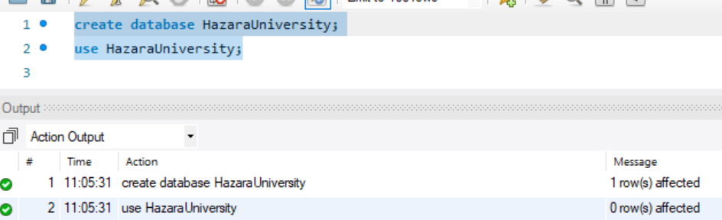

Then I have made table for the following:

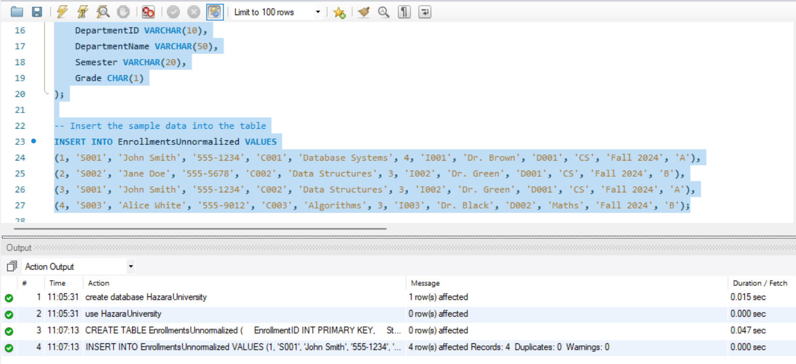

**Steps to Complete the Task**

**Part 1: Analyze the Unnormalized Data**

* Identify the redundancy, anomalies, and potential issues in the dataset (e.g., repetition of Student Name, Instructor Name, and Department Name).
* List examples of **update anomalies**, **insert anomalies**, and **delete anomalies** in the dataset.

**Answer:**

**Part 2: Apply Normalization**

1. **First Normal Form (1NF):**
   * Remove repeating groups.
   * Ensure all attributes contain atomic values.
2. **Second Normal Form (2NF):**
   * Remove partial dependencies by creating separate tables for entities like students, courses, instructors, and departments.
3. **Third Normal Form (3NF):**
   * Remove transitive dependencies to ensure that all non-key attributes depend only on the primary key.

**Part 3: Create Normalized Tables**

Break down the unnormalized data into the following tables:

1. **Students Table**
   * Attributes: Student ID, Student Name, Student Phone
2. **Courses Table**
   * Attributes: Course ID, Course Name, Credits, Instructor ID
3. **Instructors Table**
   * Attributes: Instructor ID, Instructor Name, Department ID
4. **Departments Table**
   * Attributes: Department ID, Department Name
5. **Enrollments Table**
   * Attributes: Enrollment ID, Student ID, Course ID, Semester, Grade

**Part 4: Implementation**

* Write SQL scripts to create the normalized tables in a database management system (DBMS).
* Populate the tables with the sample data provided.

**Submission Requirements**

1. A report explaining the normalization process (1NF, 2NF, and 3NF).
2. SQL scripts for table creation and data insertion.
3. Screenshots of the final database schema and query results for verification.